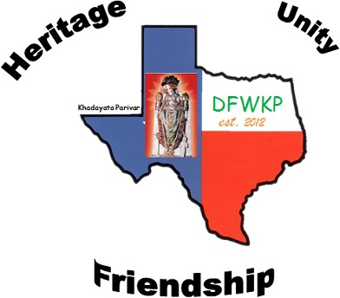
DFW Khadayta Parivar

Scholarship Application Form 2026
 | Applicant Name | Junior: Senior:___
 | High School Name and ISD
 | Name of Father
 | Name of Mother
 | Mailing Address
 | Phone Number | Email:
 | Class Rank | out of
 | SAT/ACT Scores (copy of  transcript must be attached) | SAT: out of ACT: out of PSAT out of
OTHER subject SAT/other Scores (copy of transcript
must be attached)
 | GPA | out of 4 out of 5 out of 6
 | National Merit Status (PSAT). (Attach copy of PSAT result) | Commended Semi-finalist Finalist
 | List of Your Organizational | Club Name |  | Club Role
 | Involvement in High School
 | and Role | 1. |  | 1.
 | (ex: School Clubs)
 |  | 2. |  | 2.
 |  | 3. |  | 3.
 |  | 4. |  | 4.
 |  | 5. |  | 5.
 | List All your AP, IB & Dual Credits | Subject GPA |  | Subject |  | GPA
 | Courses Taken with GPA  (Attach copy of transcripts) | 1. |  | 7.
 | Courses Taken with GPA  (Attach copy of transcripts) | 2. |  | 8.
 |  | 3. |  | 9
 |  | 4. |  | 10.
 |  | 5. |  | 11.
School Counselor Name, Email Address and Phone Number |  |  | Name: Email:  Phone Number:
List Community  Activities (Social, Business, Religious) |  |  | 1.  2.  3.  4.  5.
Future Education Plans (college or university, major, plans for future)
Recommendations from Teachers (optional/not required)
Any Other Details You Want to provide
Signature of the Candidate and Date: |  |  |  |  | Date:
Signature of the Parent and Date: |  |  |  |  | Date:  Relationship to the Candidate:
Applications and Transcripts can be sent only via Email to Renuka Shah at renukamshah@gmail.com by May 17,2026. Form is available on dfwkp.com.

Eligibility and Qualification Criteria

- All candidates should be currently enrolled in a state approved High School and be in good academic standing.
- Should have taken PSAT, SAT and/or ACT already and be a High School Senior or Junior in 2026.
- Attach copies of the HS transcripts, PSA/SAT score, class rank, letter of recommendations from Principal/ Teachers, and/or Counselor. Incomplete application and submissions will result in disqualification.
- Documents submitted will not be returned to the candidate, hence do not submit originals. Please redact SSN numbers from all documents before sending.
- DFW Khadayta Parivar decisions are final.
- Question, Contact Renuka Shah @ 214-498-6504 or renukamshah@gmail.com
- Each applicant will be sent an acknowledgement of receipt of their application. If an acknowledgment is not received by applicant, then Applicant is requested to follow up after 2 weeks.

